Amanda Miller, Kayla Carter, Angelina Reynolds
Krystal Rice, Carolina Nieto
Group Science Lesson Presentation – Force and Motion
The University of Texas at Arlington
Dr. Jiyoon Yoon
Date: 10/09/2018

Simple Group Lesson Plan
Grade: Grade 4
Topic: Force and Motion
Materials: Plastic Cups, Balloon’s, Marshmallows, Tape (clear and masking)
Hula Hoops, Pictures (Venn-Diagram), Graphic Organizer, Pencils

Objective: Students will be able to distinguish the properties of force and motion going in depth with force by teaching the difference with push and pull.

TEKS:
4.3: Scientific investigation and reasoning. The student uses critical thinking and scientific problem solving to make informed decisions. The student is expected to:
- analyze, evaluate, and critique scientific explanations by using evidence, logical reasoning, and experimental and observational testing;
4.6: The student knows that energy exists in many forms and can be observed in cycles, patterns, and systems.
D. design a descriptive investigation to explore the effect of force on an object such as a push or a pull, gravity, friction, or magnetism.

Stages of the 5E model | Time
Engage. Ask questions about object.  Ask questions about push or pull venn diagram.  Kayla and Angel - Participants  Amanda - Introduction and how the hula hoop works.  Carolina- Hand out pictures  Krystal- Leads venn diagram discussion | 3 mins.  1.) | The teacher will have a Venn-diagram made of two Hula Hoops on the board labeled (Push-Both-Pull). Using this for a pre-assessment have the students come up to the board and tape pictures under the correct sections. Asking the Bloom’s Taxonomy question.  Bloom’s Taxonomy Knowledge question: Locate the correct category for each picture? (refer to teacher answers sheet)  “Notice how angel is keeping the hula hoop up, she does this by pushing force on the hula hoop which allows it to continue moving. Watch Kayla’s see how the hula hoop is falling. That is because she is not applying enough for to keep it moving. Motion is movement. Movement can go any direction circular, straight or zig zag depending on the force that is applied.”  - If we were in an elementary school we would use the smart board for the hula hoops and have it digital.
Explore. Explain and conduct investigations  Ask questions to gather evidence to answer the question posed.  Angel - Teacher  Kayla - Launcher | 4-5 mins.  3.) | The teacher will have the students get into groups and hand them their marshmallow launcher. Before they are able to start doing the experiment the teacher will give them instructions and let them know what the expectations are from them. The students are trying to make their marshmallow go the farthest than the other group.  Go over - Scientific Theory  Bloom’s Taxonomy Comprehension & Application question: What is the distinction between push and pull? Pull is a force that moves towards you and push is a force that moves objects away from you.
Explain.  Ask questions to use new knowledge and observable evidence to construct  scientific explanations and answer initiating questions.  Inquiry question: A systematic investigation search for answer  Kayla- teaching w/ anchor chart | 5-7 mins.  2.) | This is the teaching part. The teacher will have an anchor chart that just has the vocabulary words with blank spots under them. When the teacher is explaining to the class what each are the teacher will fill in the information at that time. The students will be making the same anchor chart within their science journal, so they are able to reference it at any time needed. Remember to ask the Bloom’s Taxonomy questions in the lesson so the students are also being challenged and having to use their higher order thinking skills.  https://youtu.be/8iKhLGK7HGk  “You can’t see them, but force and motion happen around us all the time. But what is Force and Motion? Force is a PUSH or PULL on an object or objects that result in the object/objects to speed up, slow down, or stay in one place. Force causes an object to move. Motion is the change in position of an object because of force`.”  PUSH is a force that moves objects away in the direction it was pushed and PULL is a force that moves towards the direction in the pull. You guys used Force Today when you PUSHED your car door closed. Can someone tell me another example of push or pull used everyday?”  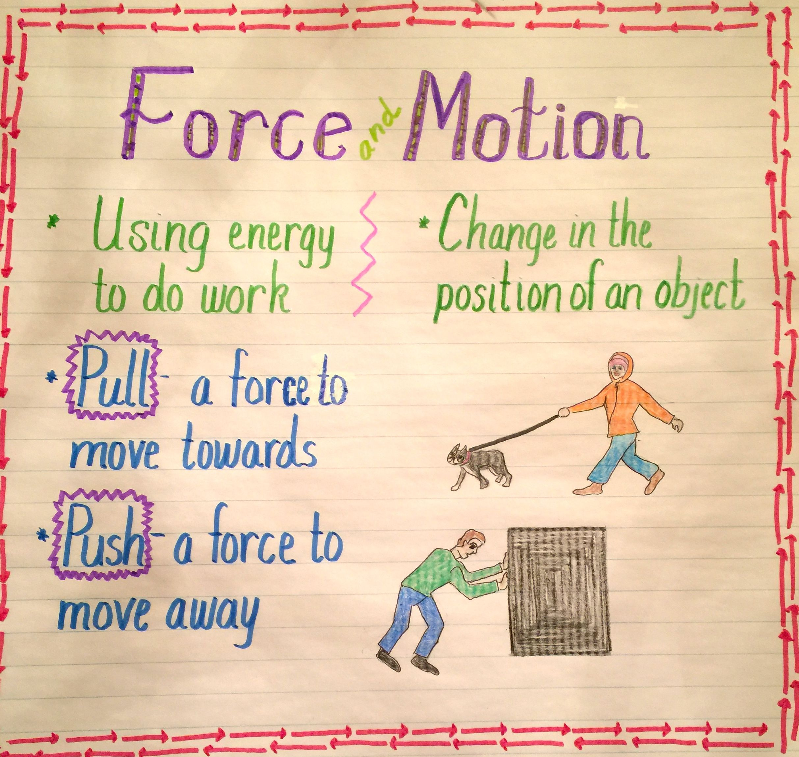  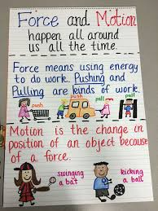  Bloom’s Taxonomy Application question: Do you know an instance where pull switches to push?  Our example would be from pulling a door open and pushing to shut it.  Bloom’s Taxonomy Analysis question: Why did the switch change from push to pull occur?  The switch occurs because the outcome is to have the door closed. We pulled the door to open it and pushed it to shut it.
Elaborate.  Ask questions to apply new understandings to new problems.  Carolina- reteach speaker  Krystal - actions and motions | 3-5 mins.  4.) | A reteach would be put right here in the case that one is needed. The teacher would ask for different volunteers (if not use the same ones from the groups) to come to the front of the classroom to help reenact the different scenes that push or pull can be done it. After a few short scenes, the teacher will ask the Bloom’s question.  Multicultural Aspect:  - Showing sports that are from around the world.  - This will help with showing the different push and pull aspects of each different sport.  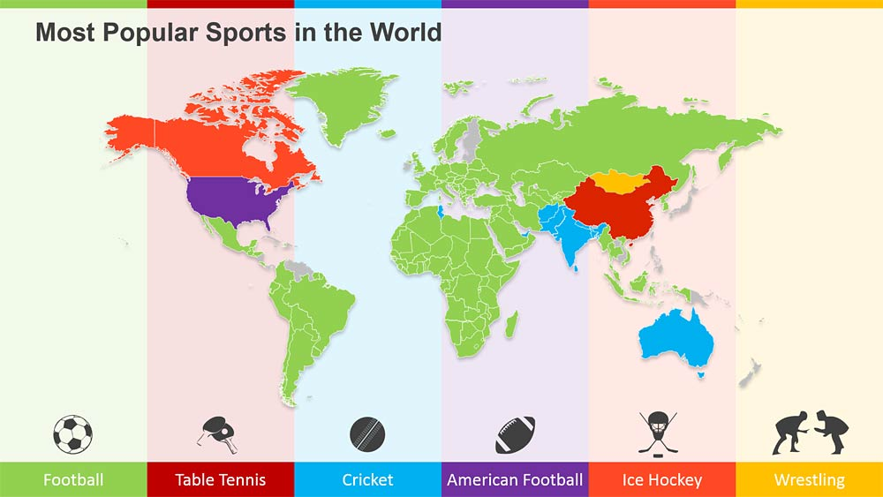    Bloom’s Taxonomy Synthesis question: What design changes would you make to your launcher to launch the marshmallow further?
Evaluate.  Ask questions to assess developing understandings and inquiry skills.  Lets rethink out review  Amanda - reviewer | 7-9 mins. | Playground Physics - iPad App  The students are able to create their own video of doing a push or pull action as an assessment. Within the video, they are able to trace the movement and they are also able to add stickers to point out important parts of the video that they would like to point out to everybody that is watching. The teacher is able to grade this easily.  Bloom’s Taxonomy Evaluation question: Can you Compare what is good and bad about force?

*****For Review for the NEXT class period, we use vocabulary words Pictionary!!!!
Evaluation Questions:
- When the marshmallows were being launched, was the launcher push or pulling the marshmallows?
- How do objects change direction?
- What stops an object in motion?
- Can you think of a sport that involves pushing something?
- In which directions can objects move?
Contributions of Group Members:
1. Kayla Carter: (Director) Brainstormed as a group to plan our lesson, helped in developing six questions based from Bloom’s Taxonomy, assisted in developing aligned activities, and compiled information into an organized format. Assigned homework for the group. Developed \

2. Carolina Nieto: (Recorder) Brainstormed with group, helped in developing six questions based from Bloom’s Taxonomy, assisted in developing aligned activities, and compiled initial questions for a shared Word document. Found and printed the pictures used in out lesson.

3. Krystal Rice: (Material Manager) Chose topic, brainstormed with group, helped in developing six questions based from Bloom’s Taxonomy, assisted in developing aligned activities, and explored additional activity ideas. Created the teacher copy for the Venn diagram.

4. Angelina Reynolds: (Recorder) Brainstormed with group, helped in developing six questions based from Bloom’s Taxonomy, assisted in developing aligned activities, helped clarify and break down how to properly develop questions based from Bloom’s Taxonomy. Bought most of the materials.

5. Amanda Miller (Speaker) - Brainstormed with group, helped develop the structure of the lesson plan. Developed Introduction to the lesson for the college class. Introduced the lesson and reviewed the lesson in the classroom. Developed the evaluation questions that will be asked at the end of the lesson in the classroom. Created the graphic organizer for the students, TEKS and Objectives sign.

References
Facts About Force: Push and Pull. (2018, August 28). Retrieved from https://easyscienceforkids.com/all-about-force-push-and-pull/

Academic Honesty Statement
On my honor, I have neither given nor received aid on this assignment. I acknowledge that misrepresenting another’s work as my own is a violation of the UTA Academic Integrity Policy. I have not submitted the attached work as an assignment for any other course of field activity.
Amanda Miller 09/16/2018
Kayla Carter 09/16/2018
Angelina Reynolds 09/16/2018
Krystal Rice 09/16/2018

Carolina Nieto 09/16/2018

Signature Date

