EC-6 ESL Science Lesson Plan

- Background Information
- Name: Angelina Reynolds
- Content Area: Science
- Topic: Objects in the Sky (Clouds)
- Grade: Kindergarten

- Goals and Objectives
- TEKS:
§112.11. Science, Kindergarten, Adopted 2017.
(8) Earth and space. The student knows that there are recognizable patterns in the natural world and among objects in the sky. The student is expected to:
(C) observe, describe, and illustrate objects in the sky such as the clouds, Moon, and stars, including the Sun.

§117.102. Art, Kindergarten, Adopted 2013.
(2) Creative expression. The student communicates ideas through original artworks using a variety of media with appropriate skills. The student expresses thoughts and ideas creatively while challenging the imagination, fostering reflective thinking, and developing disciplined effort and progressive problem-solving skills. The student is expected to:
(C) use a variety of materials to develop manipulative skills while engaging in opportunities for exploration through drawing, painting, printmaking, constructing artworks, and sculpting, including modeled forms.

- Content Objective:
The student will be able to generate and distinguish different cloud formations called Cumulonimbus, Cirrus, and Cumulus that can be found in the sky.

- ELPS:
2(D) Listening - monitor understanding of spoken language during classroom instruction and interactions and seek clarification as needed;

- Language Objective:
The student will be able to apply the knowledge from listening of the characteristics of clouds by arranging them to the correct labeled part in the sky.

The student will be able to recognize and arrange the clouds into the correct area of the sky based on applying the characteristics.

- Materials Needed:

Anchor Chart
Cotton Balls
Blue Construction Paper
Liquid Glue
Markers

- Technology Needed:
Smart board
Cloud Picture Word Document

- Pre-Assessment related to TEKS and Objectives
- “When we think of weather, what are some things that are important when looking into the sky?”
  - Sun, Clouds, Moon, Stars
- “Do we know how a cloud is formed in the sky?”
  - Water droplets that have been evaporated from the water on the ground (lakes, ponds, and oceans).
  - When it gets cold enough it creates the clouds that we can see in the sky.
- “What happens to the sun when there are clouds in the sky?”
  - The sun is still there but is sometimes blocked from our view by the clouds.
- “What are clouds able to tell us when looking at them?”
  - Gives us advance notice on what might happen soon.
- “How do clouds move across the sky?”
  - By the wind
- “Does weather stay the same every day or does it change?”
  - It changes every day and sometimes it can change in a matter of a few hours.

- Key Vocabulary:
- Cloud – made mostly of water and a tiny bit of dust
- Weather – ever-changing conditions of the air around us
- Cirrus – ice crystal clouds, change in weather
- Cumulus – white, puffy fair weather
- Cumulonimbus – strong thunderstorms
- Stratus – low, grey; rain or snow

- Instructional Procedures
- Introduction of the Topic
  - Anticipatory Set (Focus) –
    - The teacher will ask the students the open-ended question of “A cloud looks like…”
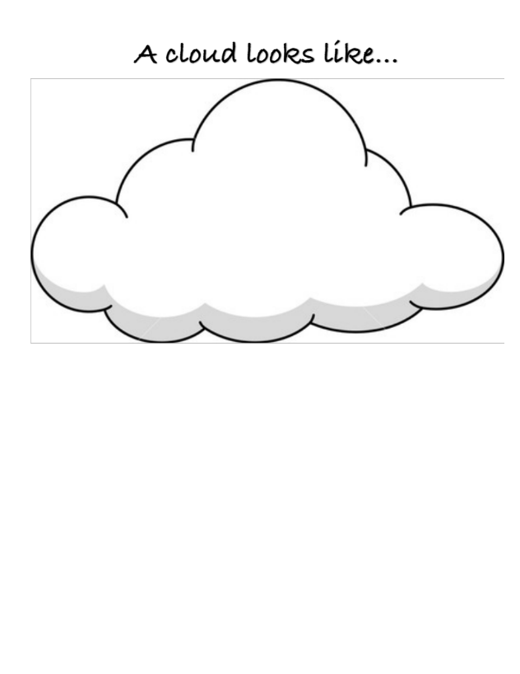
    - The teacher will write down all of the students’ responses, so all the students feel like they voice is being heard.

- Development of the Topic (Short and precise)
  - Teaching: Input –
    - First looking at cloud pictures of one type at a time that is located on the “Cloud Picture Word Document” starting with the lowest level of clouds to the highest.
    - This anchor chart will start off empty then the teacher and the students will fill it out together when looking at the cloud pictures.
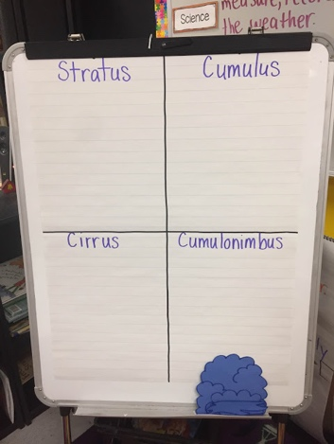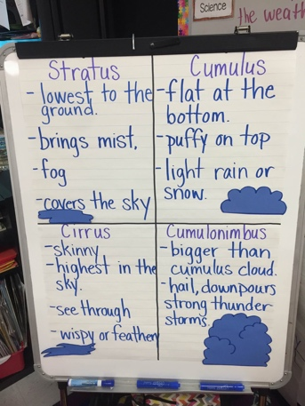
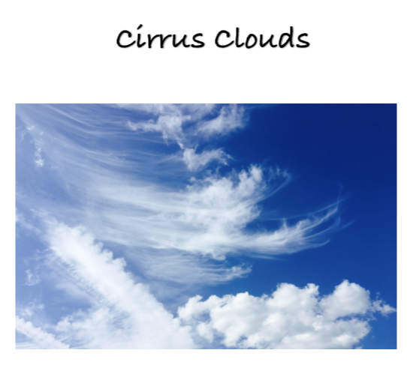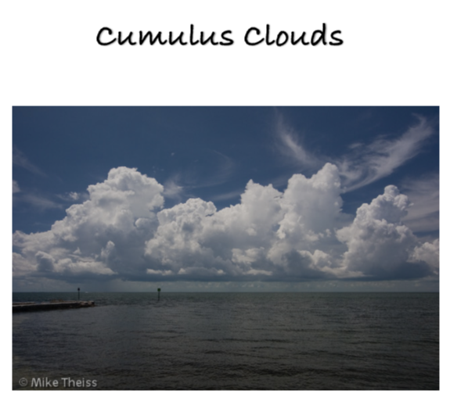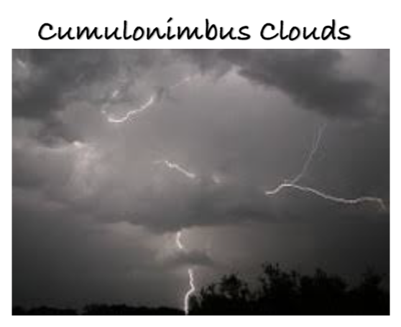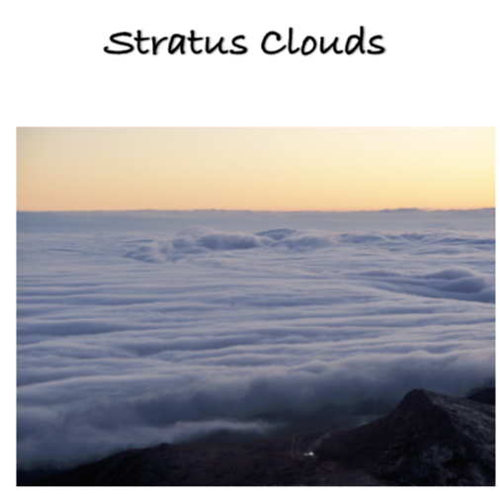

- Cirrus
  - Ice crystal
  - Skinny
  - Highest in the sky
  - Wispy or Feather
- Cumulus
  - Flat at the bottom
  - Puffy on top
  - White
  - Fair Weather

- Cumulonimbus
  - Strong Thunderstorms
  - Hail
  - Clouds built onto of each other
- Stratus
  - Lowest to the ground
  - Mist
  - Fog
  - Covers the sky
  - Rain Clouds

  - Teaching: Modeling –
    - The teacher will show the students how to create the “Types of Clouds” art piece they will be creating.
    - The teacher will show the students how to pull apart the cotton balls, so they look like the different types of clouds they are talking about that can be found in the sky.
    - The teacher will also show the students how much glue to put down in order for the cotton balls to stick to the paper.
    - While the teacher is creating the different types of clouds making sure to talk more about the different characteristics of each.

  - Guided Practice –
    - The students will create their own “Types of Clouds” following the model that was presented beforehand and explained.
    - The students will first create their title on the top of the construction paper.
    - Labeling with a crayon the highest layer of cloud type (Cirrus).
      - Then Cumulus Clouds
      - Then Stratus Clouds
    - The student will create the clouds with cotton balls and glue.
    - On the Cumulonimbus clouds the student will take a black or grey marker and tap around a few times to make the cotton balls look like storm clouds.
    - The student can also include a sun and grass along the bottom to make it look more realistic for them.

  - Checking for Understanding–
    - The teacher will have the four-part chart either printed out or created on big paper, so the students are able to place the different characteristics under each section.
    - The teacher will read out each strip of paper to the students and have them decide where it goes.
    - These are the same characteristics that were talked about previously while doing the anchor chart.
    - There will also be a picture for each that needs to be added to each column.
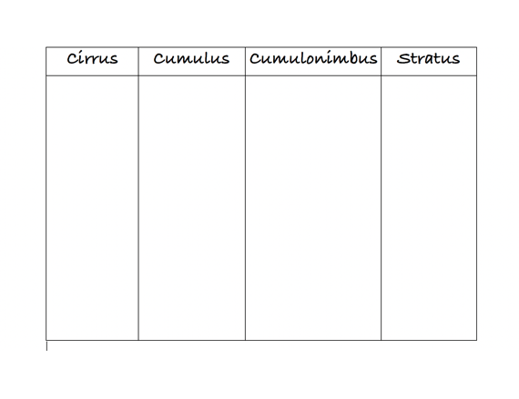
- Re-Teaching
  - Match the Cloud Shapes
    - The students will get a bag that is filled with the different types of clouds and they have to match them up together.
    - On the clouds there will be a characteristic that goes with that type of cloud and the students have to make sure that the two matching goes with each other.
    - https://classroom.synonym.com/cloud-activities-kindergarten-7866129.html

  - Modifications
- ESL
  - Beginning
    - Use gestures and movements when explaining the different vocabulary words.
      - i.e. raise my hands really high when talking about Stratus clouds because they are really high in the sky.

  - Intermediate
    - Give the students a word bank for when they are filling out the “Types of Clouds” art project.

  - Advanced / High
    - Allow extra time when the academic material is complex
      - If the student a few minutes of wait time to be able to process information efficiently.

- Extensions
  - The student will be able to play this online game that helps them learn more about the characteristics that each type of clouds has and compares to one another.
    - https://www.quia.com/mc/1172450.html

  - Have the student choose their favorite cloud and write a few sentences about that cloud type.

F. Assessment
- Independent Practice –
  - The students are to draw line connecting the different clouds to their name that matches.
  - The teacher will be able to easily grade and collect data to see if a reteach is needed.
  - On the back of the page the student then can draw their own version of what a cloud would look like in the sky.

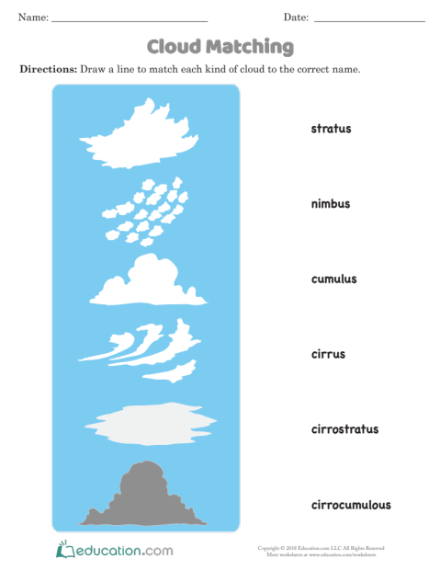
- Summary for the Students of What Has Been Learned
- Closure –
  - “Students remember when we look up at the sky we can see clouds and they can be formed in many different ways.”
  - “We also have learned that clouds are formed by water that comes from the ground and when the cloud gets to heavy and can’t hold anymore it rains.”
  - “When we are trying to figure out the different types of clouds in the sky we can look at the color of the clouds, where they are located in the sky, and how the bottom of the clouds looks to name that type of cloud.”
  - “We also know that clouds are moved in the sky by wind.”
References

19 TAC Chapter 74, Subchapter A, ELP Standards. (2007, December 25). Retrieved November 18, 2018, from http://ritter.tea.state.tx.us/rules/tac/chapter074/ch074a.html
19 TAC Chapter 112, Subchapter A, Science. (2018, August 27). Retrieved November 11, 2018, from http://ritter.tea.state.tx.us/rules/tac/chapter112/ch112a.html
19 TAC Chapter 117, Subchapter A, Fine Arts. (2013, July 28). Retrieved November 18, 2018, from http://ritter.tea.state.tx.us/rules/tac/chapter117/ch117a.html
Concepcion. (2018, January 16). I'm baaaaaack!!!! [Web log post]. Retrieved November 18, 2018, from http://teacherificfun.blogspot.com/
Gibson, J. All About Weather: Clouds | Lesson Plan | Education.com | Lesson plan. (2018, July 12). Retrieved November 18, 2018, from https://www.education.com/lesson-plan/all-about-weather-clouds/
Videos, L. T. What's A Cloud? (2011, November 11). Retrieved November 18, 2018, from https://www.youtube.com/watch?v=4MH4zBDjhUk
(2017, June 11). Retrieved November 18, 2018, from https://pixabay.com/en/sky-cloud-blue-clouds-form-2390929/
(n.d.). Retrieved November 28, 2018, from https://i.pinimg.com/1200x/75/f1/ba/75f1ba2806245bb1834cb7046dce0b56.jpg
(n.d.). Retrieved November 18, 2018, from https://sites.google.com/a/granitesd.org/research/cloud-types/cumulus-clouds
(n.d.). Retrieved November 18, 2018, from https://sites.google.com/a/granitesd.org/research/cloud-types/stratus-clouds

