K: What I know…  - Traditions for Christmas very from region, country, culture and religion. Coming from a Mexican heritage, Christmas traditions have continued through the years. We follow some here in the U.S.  - However, the true traditions are followed in our small town in Mexico. Unfortunately, we have not had the opportunity to visit our hometown for more than a decade during the holiday season.  - Never the less, we continue traditions here in Texas with our friends and family. A Mexican grocery store or supermarket shows many traditions including, piñatas, and nochebuena flowers.  - Foods are also displayed such as Buñuelos, tamales, posole and ponche. Yet, I continue to discover new traditions that come with the holiday season and my heritage. | Y: What I want to know…  - As I mentioned previously, it has been a long time since I have experienced the holidays in my hometown.  - I would like to know which traditions are continued to be used from when I has last there. I would also like to know if new “modern” traditions have started.  - I would like to know if the traditional foods are being eaten and if the celebrations are as large as I remember. Over all  - I would like to know if the new generation from this last decade has made an influence in the traditions or if they continue to be passed down as usual. | L: What I learned…  - After speaking to a lovely woman that works in the bakery department of the Fiesta grocery store, I was informed a little bit more on recent traditions.  - I discovered that she is from an area close by to where I live in Mexico, and she had the pleasure of being in Mexico last Christmas. She told me that many religious traditions continue as they have before.  - The food is similar to the foods that I ate when I was there. She tells me that now they have created many new flavors of tamales including, strawberry and pineapple.  - Ponche, a traditional tea like drink made with real fruit and sugar cane sticks continues to be a must have drink of the season.  - The kids continue to have the joy of breaking a piñata. She does inform me that now the piñatas consist of only candy. When I was young the piñatas also had fresh fruit.  - One thing that was new to me is that now people decorates their homes with Christmas lights. The last time that I was there not one home had Christmas lights, and even having a Christmas tree was rare.  - It seems that some new traditions have begun to rise, perhaps from the people that have previously been to the U.S. I was very Excited to know that many of the traditions that I remember continuing on, and it really makes me excited to visit my hometown in Mexico in the future for the holidays.

I really enjoyed exploring new and old traditions of my culture. I am currently in a classroom that includes students from many different backgrounds. I would really like to integrate some traditions from my student’s background in the classroom. I know Christmas is a sensitive subject because of the religious aspect of it. I would still like to try talking to the parents and hopefully they can provide a tradition for the holidays that they do in their home. I would like to include my student’s culture throughout the year, not just Christmas. I know students enjoy sharing things about them and I know they would all like to know more about each other. I would definitely like to share things about my background and culture and I know I enjoy learning about new cultures as well. I would like my classroom to be a tightknit community where my student can feel safe sharing and openly talking about themselves and their family. It would be incredible if I can get the parents on board to create a wonderful event together. If not, students can bring in things to show-and-tell for the class.

Buñuelos, made from very thin dough, fried and covered in sugar and cinnamon 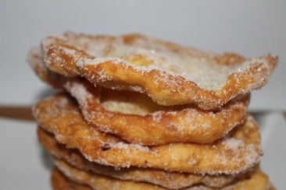
Nochebuena flower, also known as poinsettia
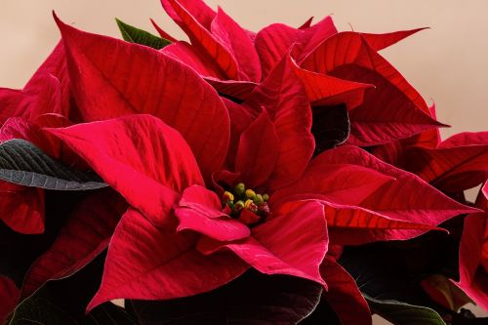
Piñatas: filled with candy, treats and broken with a stick
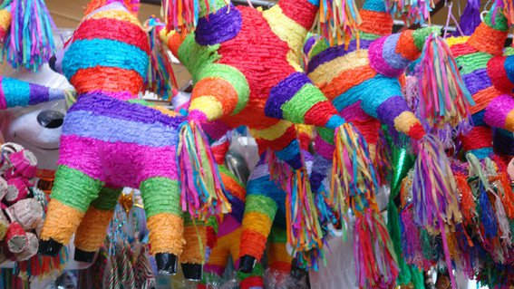
Ponche: A slow cooked tea that is made with fresh fruit and sugar cane sticks, served hot
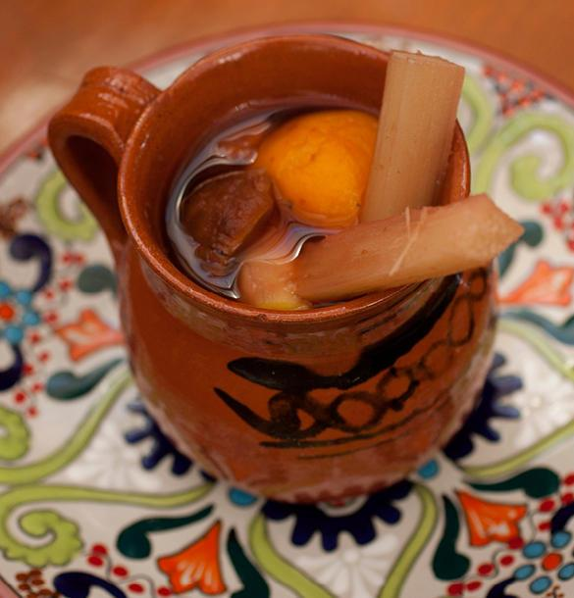
Tamales: Filled with a variety of meats, cheeses, and sweet fruit or even peanuts
